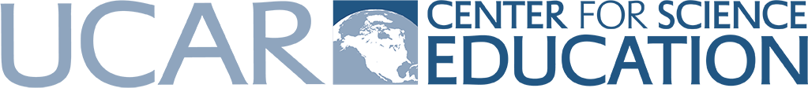
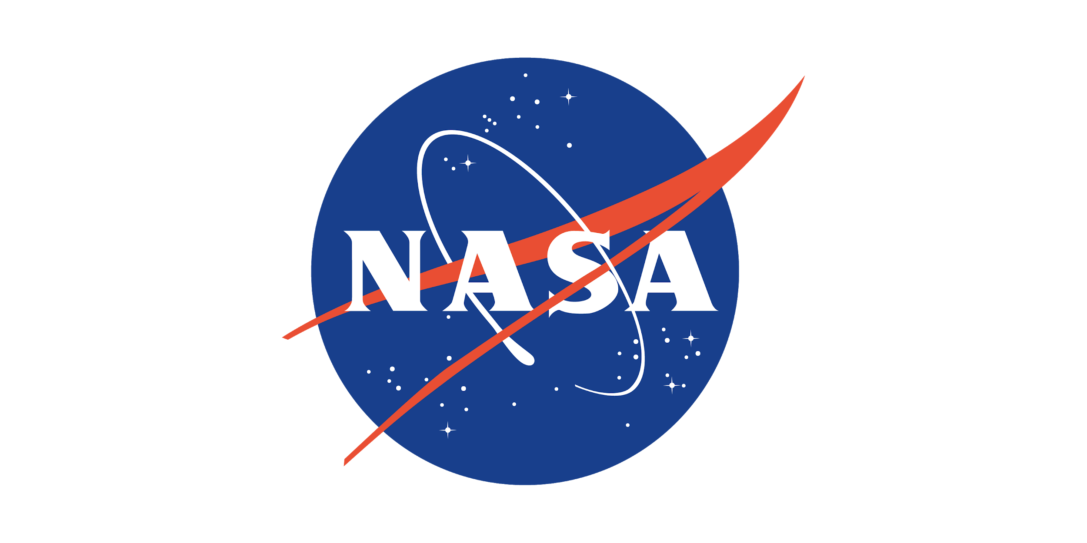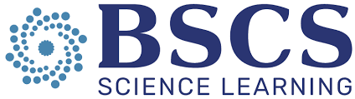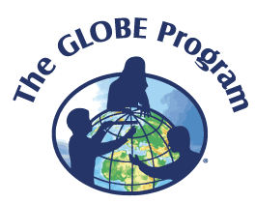

Workshop Information: GLOBE Weather: A New NGSS-Based Middle School Unit
NASA Langley Research Center
August 19-21, 2019
Workshop Description:
We will share a new, free unit about the science of weather that combines activities, data analysis, modeling, and weather measurements using GLOBE Program protocols. The curriculum helps students understand NGSS-based weather concepts such as the uneven heating of the Earth, local and global atmospheric circulation, and air mass formation and collision as they investigate weather patterns and extreme weather events that we experience.

Workshop Learning Outcomes:
- Orientation to the GLOBE Weather curriculum
- Explore weather concepts with modeling, data analysis and hands-on activities
- Introduction to GLOBE program & certification in GLOBE Atmosphere protocols

UCAR Contacts:

Becca Hatheway  Manager of Teaching and Learning  UCAR Center for Science Education  hatheway@ucar.edu | Emily Snode-Brenneman  Program Specialist  UCAR Center for Science Education  emilysb@ucar.edu

Workshop Resources

GLOBE Weather website: globeweathercurriculum.org
- Full curriculum available via free download

Web link to NASA Langley workshop materials:
- https://scied.ucar.edu/events/globe-weather-workshops

UCAR Center For Science Education Learning Zone: scied.ucar.edu/resources
- Atmosphere related activities, Teaching Boxes, videos, games, and more for students and teachers

The Inquiry Project: https://inquiryproject.terc.edu/
- Curriculum, videos, research, and PD to support using inquiry & productive talk in the classroom
- Talk Moves Checklist: https://inquiryproject.terc.edu/shared/pd/Goals_and_Moves.pdf
- Talk Science Primer; a research based introduction to productive talk: https://inquiryproject.terc.edu/shared/pd/TalkScience_Primer.pdf

Visible Thinking: http://www.visiblethinkingpz.org
- Thinking routines to structure productive talk and help build a culture of talk in your classroom: (http://www.visiblethinkingpz.org/VisibleThinking_html_files/03_ThinkingRoutines/03a_ThinkingRoutines.html)
- The thinking routines are the result of Harvard School of Education research called Project Zero (http://www.pz.harvard.edu/projects/visible-thinking)

Kagan Cooperative Learning:
- The Essential 5: A starting point for using Kagan Cooperative Learning https://www.t2tuk.co.uk/downloads/The%20Essential%205.pdf

Liberating Structures:
- http://www.liberatingstructures.com/1-1-2-4-all/

GLOBE Atmosphere Protocols: https://www.globe.gov/do-globe/globe-teachers-guide/atmosphere
- Students and scientists investigate the atmosphere through the collection of data using measurement protocols.

GLOBE Program: globe.gov
- GLOBE Observers (Citizen Scientists)
  - A free app-based citizen scientist initiative collecting data about clouds, mosquito habitats and larvae, and land cover in 120+ countries. Visit the Get Started tab on the GLOBE website to learn more.

- GLOBE Teachers/Educators
- Through The GLOBE Program, teachers can connect students to an international network of students, teachers and scientists while learning more about our shared environment. For a school to fully participate in The GLOBE Program, at least one teacher must be trained in GLOBE science measurement protocols and education activities. Training is key to gaining knowledge and skills to implement GLOBE science protocols and activities in a school setting. Visit the Get Started tab on the GLOBE website to learn more.

Forestry Suppliers: https://www.forestry-suppliers.com/Search.php?stext=GLOBE
- Official GLOBE supplier for classroom weather instruments

