Features of GLOBE Weather Scavenger Hunt!
Feature: | Notes about how to use these features:
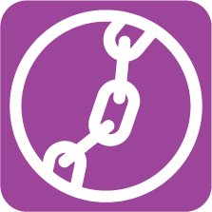
Storyline link
NGSS Sensemaking
Assessment
Home Learning
Literacy Connection
Dig Deeper
More information
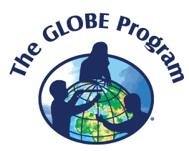
Connections to GLOBE
Stop and Do
Stop and Think

Feature: | Notes about how to use these features:
What I What It
See Means
Science & Engineering Practices

Disciplinary Core Ideas

Cross Cutting Concepts

NGSS 3-Dimensions
Work Alone
Work in a Group

Inquiry 5E’s

